The Clock is Ticking!

Only 9 days left!
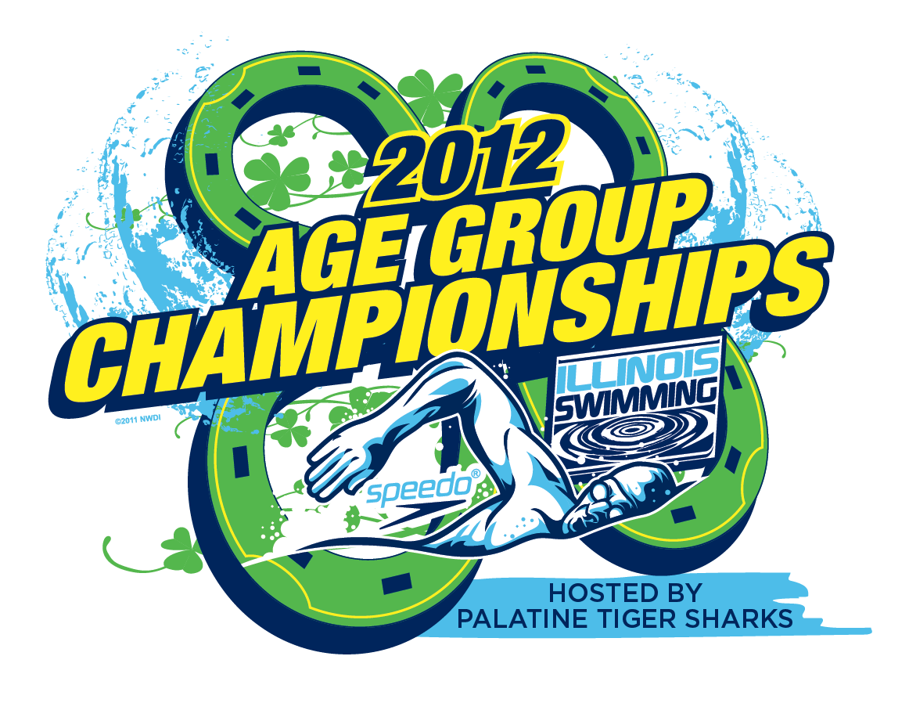
Get your orders in now for personalized Age Group Banners!
Orders must be received by Wed. February 22, 2012.

As the host team for the 2012 SCY Age Group Championship Meet March 9-11, 2012, Palatine Park District Swim Team is offering a unique opportunity! Get a personalized banner with your child’s name, one of three slogans and a personal message along with this year’s Age Group Championship Logo. The banners are 2 1/2 feet long by 3 1/2 feet wide. They are digitally printed on vinyl with two metal grommets for hanging. We will hang the banners at UIC for the duration of the meet, after which you or your child may claim your banner and take them home with you for a keepsake. You can purchase banners for any swimmer, any team, even if they are not swimming at this meet.

Order forms are available on our website - ppdswim.org - click on the Age Group Champs icon located on the right side if the screen. There is a picture posted on our website as an example of what the banners will look like. The order form and photo of the banner are located under the spectator section of the page. Orders must be received with a check made payable to Palatine Swim Team by Wednesday, February 22, 2012. Any orders received after the due date will be returned.

If you have any questions, please contact Liz Rodney at liz.rodney@gmail.com

